How to run automatically Xampp in background without signing in to pc.  
  
1. Open xampp as Administrator:  
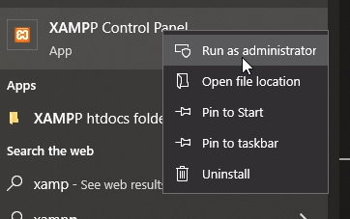  
  
2. Install services Apache and MySQL.  
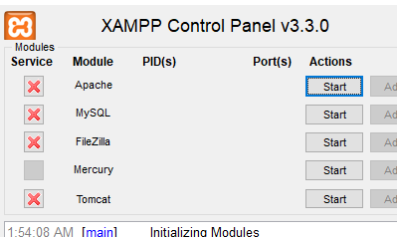  
  
3. Once both service are installed.   
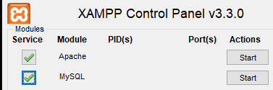  
  
4. Start service and check Services.msc if both services are running into the system.  
  
5. Click on Config.  
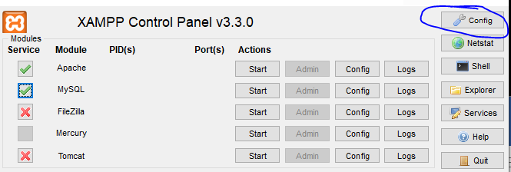  
  
6. Then Click on Autostart of module Apache and MySQl. Then save it.  
  
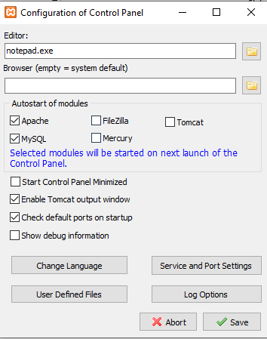  
  
7. Then search for Task Scheduler:  
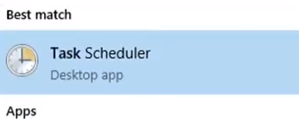  
  
8. Click on Task Schedular Library:  
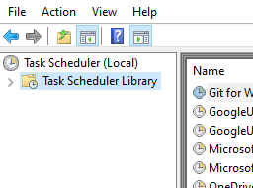  
  
9. After that, Select Action from top and Create new Folder.   
  
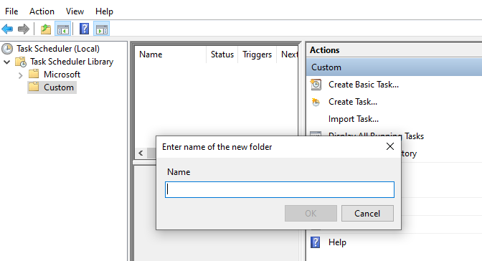  
  
10. Then Select Action and Click on Create task.  
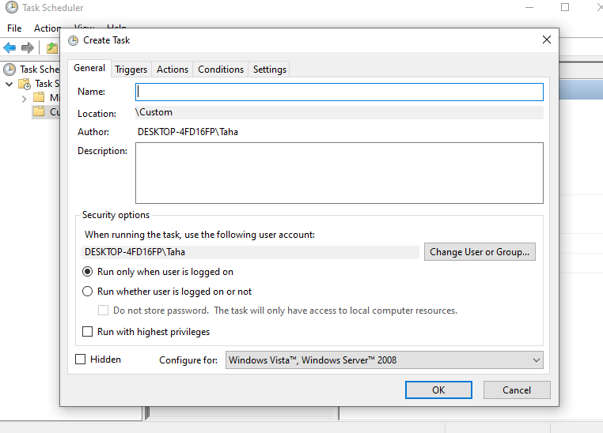  
  
11. Fill name and Click on the checkbox “RUN WHETHER USER IS LOGGED ON OR NOT” and “RUN WITH HIGHT PRIVILEGES”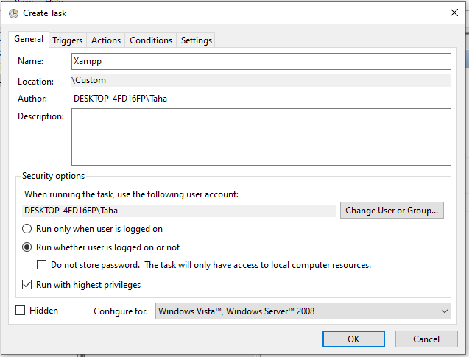  
  
12. Then Select Triggers Tab and Begin the task as “At Startup”  
  
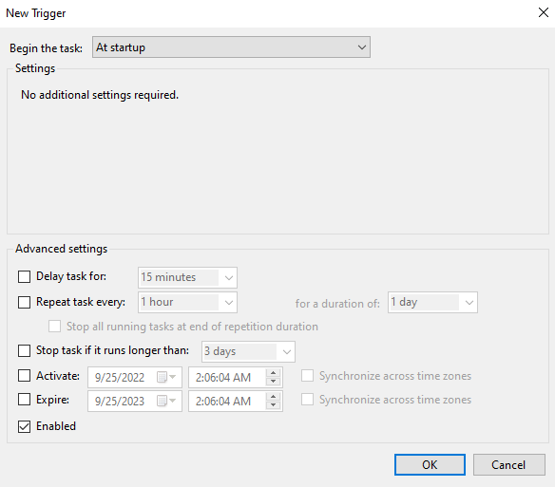  
13. Then Click on Actions and Select New. And Browse for the xampp and Click on Ok.   
  
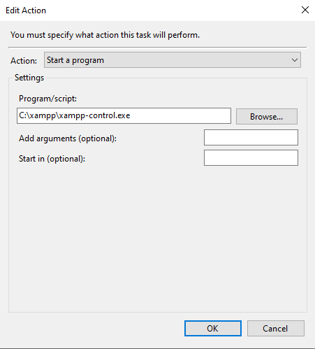  
  
14. Then Save the progress and it will ask you for the password.   
Fill and save it.  
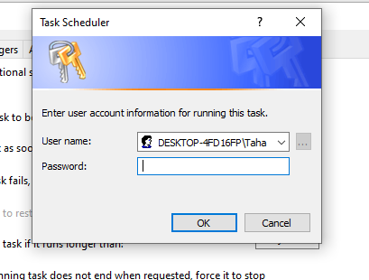  
  
  
Enjoy!